PROJECT REPORT
AI-Powered Code Analysis & Auto-Patching Agent

Course | Data Structures & Algorithms
Author | Duy
Date | May 2026
Language | Python 3.13 / Node.js
Database | PostgreSQL (codex_db)

Studied from: GitNexus | Gastown | and others (see References)

Table of Contents

1 Introduction
2 Methodology
3 Data Structures
4 Depth-First Search (DFS)
5 Implementation
6 Challenges
7 Results
8 Future Work: Monte Carlo Tree Search (MCTS)
9 Conclusion
References

Abstract
This report documents the design, implementation, and evaluation of an AI-powered code analysis and auto-patching agent. The system ingests arbitrary source-code repositories, constructs a semantic program graph, assigns explainable universal graph node weights, and applies graph-traversal algorithms - most notably Depth-First Search (DFS) - to reason about call relationships, propagation risk, and latent code defects. Patch candidates are generated, scored, and either applied automatically or queued for human review depending on a computed risk level. The project draws conceptual inspiration from open-source tools including GitNexus and Gastown, and identifies Monte Carlo Tree Search (MCTS) as a compelling direction for future enhancement of the patch-selection strategy.

1 Introduction

1.1 Background
Modern software repositories grow faster than manual review cycles can keep pace with. Developers regularly introduce subtle defects such as overwritten variables, inconsistent return types across code paths, and trivially dead conditional branches. Static linters catch some of these, but they operate on isolated files and lack awareness of cross-module call semantics.
This project explores a richer approach: build a semantic program graph that models every file, symbol, call-site, and execution-flow step in a repository, then apply graph algorithms to reason about risk and generate targeted patches. The agent is designed to work with any language supported by the tree-sitter parser family, making it broadly applicable across Python, TypeScript, C#, Go, Rust, Java, and more.

1.2 Objectives
- Parse source files into a unified, language-agnostic program graph.
- Implement DFS-based traversal to trace call chains, discover impact zones, and surface root causes.
- Score symbols by propagation risk using graph-topology metrics.
- Compute universal graph node weights from normalized in-degree, out-degree, and complexity so traversal and exported summaries prioritize structurally important nodes.
- Generate and rank multiple patch candidates using a lightweight scoring heuristic.
- Persist engineering knowledge across sessions via a PostgreSQL-backed agent memory system.
- Identify MCTS as the next evolution of the patch-selection decision process.

2 Methodology

2.1 System Overview
The system is structured into five layers, each with a distinct responsibility:

Layer | Module(s) | Responsibility
Parsing | core/code_parse.py, graph/builder.py | Tree-sitter AST to ProgramGraph nodes and edges
Graph | graph/schema.py, graph/query.py, graph/compressor.py, graph/weights.py | Store, query, weight, and compress the program graph
Traversal | core/graph_walker.py, graph/query.py | DFS for call-chain walking and path tracing
Reasoning | reasoning/reasoning_engine.py, reasoning/decision_engine.py | Risk scoring and patch-action decisions
Patching | patching/patch_planner.py, patch_synthesizer.py, patch_plan_executor.py | Intent -> candidates -> scored patch -> apply
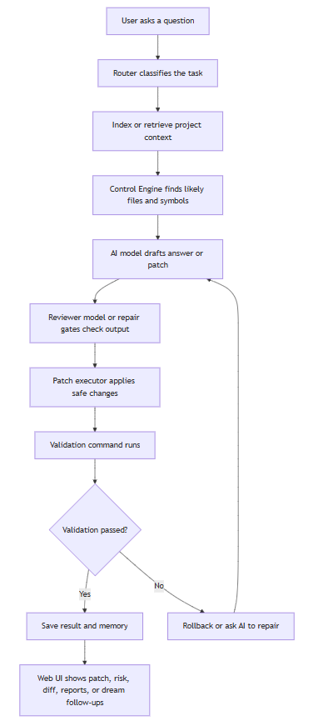
Figure 1: End-to-end workflow of the AI agent — from repository ingestion and graph construction through DFS traversal, hypothesis ranking, and patch synthesis.

2.2 Technology Stack
- Python 3.13 — primary runtime for all analysis and patching logic.
- Python 3.12 (secondary venv) — required by tree-sitter for AST parsing.
- tree-sitter — incremental, language-agnostic parser producing concrete syntax trees.
- PostgreSQL (codex_db) — persistent storage for agent memory, session messages, and engineering notes.
- Google Gemini API — LLM backbone for memory extraction and patch-refinement prompts.
- DeepSeek API (optional) — alternative LLM with local Ollama fallback.
- Obsidian Vault export — visual graph exploration via GRAPH_SUMMARY.md.

2.3 Multi-Language Support
A configuration map (LANGUAGE_MAP) associates file extensions with parser identifiers. The current implementation covers Python, JavaScript/TypeScript, C/C++, C#, Go, Rust, Java, Kotlin, HTML, and CSS. The Code DNA module (core/code_dna.py) fingerprints each repository's style preferences — indentation width, naming convention, brace style, and average function length — so that generated patches blend seamlessly with the existing codebase (see Figure 1).

3 Data Structures

3.1 The ProgramGraph
The central data structure is ProgramGraph, a directed multigraph defined in graph/schema.py. It consists of two collections:

Component | Type | Description
nodes | dict[str, GraphNode] | Keyed by a unique node ID (e.g. core/foo.py::bar)
edges | list[GraphEdge] | Directed edges carrying a typed relationship label

GraphNode carries four fields: id (unique string key), type (file | function | class | expression | call), label (human-readable name), and a metadata dictionary for extensible properties. GraphEdge carries source, target, type, and metadata.

3.2 Node Types and Edge Types
Five node types model the full structure of a program:
- file — a source file, identified by its repository-relative path.
- function / class — top-level symbols extracted from the AST.
- expression — significant sub-expressions within a function body (used for fine-grained execution flow).
- call — a temporary placeholder node created during parsing, later resolved into a resolved_call edge.
Four edge types capture relationships:
- imports — file A imports file B (resolved from tree-sitter import nodes).
- contains — file contains symbol; symbol contains expression.
- calls — a raw, unresolved call reference (e.g. call::json_loads).
- resolved_call — the disambiguated edge after resolve_call_edges() matches call:: placeholder nodes to actual symbol nodes across the graph.

3.3 Graph Construction Pipeline
Building the graph from a repository involves four sequential passes:
- File enumeration — repo_librarian.iter_repo_files() walks the directory tree, skipping .git, __pycache__, venv, node_modules, and other non-source folders.
- AST parsing — tree-sitter parses each file into imports (module paths) and symbols (name, kind, calls list, execution_flow list).
- Node/edge insertion — files, symbols, expressions, and call placeholders are added to the graph with appropriate edge types.
- Call resolution — resolve_call_edges() iterates every call:: placeholder, looks up the matching symbol by name, and replaces the placeholder with a resolved_call edge connecting the caller directly to the callee.
The result is a rich, queryable multigraph that captures the full semantic shape of the repository at symbol granularity. A caching layer (semantic_graph_pipeline._graph_cache) ensures the graph is built only once per repo path per session.

3.4 Module-Level Compression
For large repositories the symbol-level graph can contain tens of thousands of nodes. graph/compressor.py provides compress_to_modules(), which groups every node by its parent directory and aggregates inter-module edges. This produces a coarser view suitable for high-level architectural summaries and token-efficient LLM prompts.

3.5 Universal Graph Node Weights
A recent extension centralizes graph importance in graph/weights.py. Instead of allowing traversal, project maps, and Obsidian export to invent separate hotspot formulas, compute_node_weights(graph) returns one shared NodeWeight record for each semantic node.
Each NodeWeight stores node_id, node_type, in_degree, out_degree, complexity, weight, optional penalty, and human-readable reasons. Noise nodes such as call:: placeholders and ::expr:: execution fragments are excluded by default so rankings focus on files, functions, classes, and other meaningful program symbols.
The structural formula is: weight = 2.0 x normalized_in_degree + 1.0 x normalized_out_degree + 0.5 x normalized_complexity. The coefficients alpha=2.0, beta=1.0, gamma=0.5 encode a deliberate design priority. Incoming references (callers and importers) receive the largest weight because a widely-called node has the greatest blast radius when changed -- a property established in classical change-impact analysis. Outgoing references identify orchestrators: nodes that call or import many others tend to be integration points whose behaviour ripples outward. Complexity contributes a smaller coefficient because structural connectivity is a stronger predictor of change risk than local code density. The linear decomposition was chosen for interpretability: each term has a clear semantic meaning, and any coefficient can be set to zero to ablate that signal without breaking the formula.
The model adapts the meaning of degree and complexity to node type. Function nodes use resolved_call edges; file nodes use imports and contained symbols; class and type-like nodes use contained children. This makes the metric language-agnostic while still respecting the structure captured by the ProgramGraph.
Graph weight is deliberately separate from patch risk. Weight answers "where should the agent look first?" while risk_score answers "how dangerous is it to modify this symbol?" Keeping the two signals separate prevents an important node from being treated as unsafe by default.

4 Depth-First Search (DFS)
DFS is used in two distinct roles inside the project: bidirectional call-chain traversal (graph_walker) and single-path tracing between two named symbols (graph/query). Both are recursive implementations with explicit visited-set tracking.

4.1 Bidirectional DFS — walk_from_nodes
The walk_from_nodes function in core/graph_walker.py starts from a set of seed nodes and fans out in both directions simultaneously:
def walk_from_nodes(graph, start_nodes, max_depth=2):
visited = set()
paths = []
def dfs(node, path, depth):
if depth > max_depth or node in visited:
return
visited.add(node)
path.append(node)
for caller in info.get('called_by', [])[:2]: # backward
dfs(caller, path.copy(), depth + 1)
for callee in info.get('calls', [])[:2]: # forward
dfs(callee, path.copy(), depth + 1)
paths.append(path)
for n in start_nodes:
dfs(n, [], 0)
return paths
At each node, explain_symbol (graph/query.py) is called to retrieve its callers and callees from the resolved_call edges. The [:2] slice bounds branching factor to prevent combinatorial explosion on hub nodes. Each recursive branch operates on an independent copy of the path list, preserving the full lineage up to that point.
Seed nodes are determined by get_ai_top_nodes(), which exports the graph to an Obsidian Vault, reads the AI_READ_FIRST section of the generated GRAPH_SUMMARY.md, and extracts the top-K highest-weight semantic nodes. Because AI_READ_FIRST now uses the universal graph-weight ranking, DFS starts from nodes with high blast radius, orchestration value, or local complexity rather than relying on a degree-only heuristic.

4.2 Path-Tracing DFS — trace_path
graph/query.py provides a second DFS variant specialised for finding all call paths between a named source and a named target symbol:
def trace_path(graph, start, end, max_depth=5):
paths = []
def dfs(current, path, depth):
if depth > max_depth: return
if current.endswith(f'::{end}'):
paths.append(path[:])
return
for edge in graph.edges:
if edge.type == 'resolved_call' and edge.source == current:
dfs(edge.target, path + [edge.target], depth + 1)
for node in graph.nodes:
if node.endswith(f'::{start}'):
dfs(node, [node], 0)
return paths
This variant uses suffix matching (endswith) rather than exact ID equality, correctly handling cases where the same function name exists in multiple files. All paths up to max_depth=5 hops are collected and returned, giving the reasoning engine a complete picture of how one symbol can transitively reach another.

4.3 Impact Analysis via Graph Traversal
impact_analysis(graph, symbol_name) complements the two DFS routines by collecting the immediate set of callers (one hop only) of a given symbol. This is a linear scan over all resolved_call edges and answers the question "which symbols will break if this one changes?" — a critical input to the risk-scoring step.

4.4 Complexity Analysis
Both DFS implementations are bounded by the max_depth parameter, giving a worst-case time complexity of O(b^d) where b is the branching factor (effectively capped at 2 for walk_from_nodes) and d is the depth limit. The visited set in walk_from_nodes reduces the practical cost on DAG-like call graphs significantly. For typical Python or TypeScript repositories, traversal completes in milliseconds.

4.5 Weighted DFS Neighbor Ordering
The Control Engine (core/control_engine.py) is the central orchestration layer that coordinates weighted DFS traversal, hypothesis ranking, Gemini prompt construction, and patch validation into a single repair pipeline. It uses graph node weights when ordering DFS neighbors: for tied or weakly matched query terms, neighbor_score = query_bonus x 2 + graph_weight, so a structurally important callee or caller is visited before a less connected sibling. The algorithm still keeps all reachable nodes eligible; the weight changes priority, not reachability.
CONTROL evidence now includes graph_weight beside the risk object. This makes the reasoning context explainable: a reader can see whether a node ranked highly because it matched the user query, because it had many callers, or because the universal graph metric identified it as central.

5 Implementation

5.1 Reasoning Engine
reasoning/reasoning_engine.py builds on the graph primitives to produce a risk profile for each candidate symbol. The risk score is computed as:
risk_score = 1 + (len(callers) * 2) + len(callees)
Callers are weighted more heavily than callees because changing a symbol ripples upward to every caller. Thresholds map the numeric score to a qualitative level: score >= 6 yields high, >= 3 yields medium, otherwise low. The reasoning context string produced by build_reasoning_context() is injected directly into LLM prompts, giving the language model structured evidence before it generates a patch.

5.2 Universal Weight Module
graph/weights.py implements compute_node_weights(), get_node_weight(), and rank_nodes_by_weight(). The module scans the existing ProgramGraph on demand, normalizes in-degree, out-degree, and complexity, and returns immutable NodeWeight records. This keeps graph construction lightweight while allowing multiple consumers to share the same definition of structural importance.
The module fails soft: an empty graph returns an empty metrics map, missing nodes default to weight 0.0, and unexpected edge types are ignored. This matters because graph weighting should improve ranking, not block indexing, retrieval, patching, or report generation.
Three consumers currently use the universal metric. core/control_engine.py adds graph_weight to evidence and uses it for DFS neighbor ordering; graph/project_map.py ranks Critical Symbols with rank_nodes_by_weight(); and graph/obsidian_exporter.py uses the same ranking for AI_READ_FIRST. When repo_path is supplied, graph/penalty.py can add a lesson-based penalty for nodes with previous blocked lessons or transient patch failures, causing recurring trouble spots to be inspected earlier.

5.3 Decision Engine
reasoning/decision_engine.py translates risk level and detected issue count into a patch action:

Risk Level | Action | Base Confidence | Adjustment
High | require_review | 0.30 | -0.20 if >= 2 issues
Medium | safe_patch_with_check | 0.60 | +0.20 if issues found
Low | auto_patch | 0.80 | +0.20 if issues found

5.4 Patch Synthesis
patching/patch_planner.py classifies a detected issue into one of three categories — overwritten assignment, return conflict, or trivially dead branch — and constructs a patch intent dictionary. patch_synthesizer.py then expands each intent into multiple concrete patch candidates, each tagged with a strategy name:
- remove_last_assignment — excises the overwriting line.
- swap_assignments — reorders the two conflicting assignments (guarded by _is_safe_swap to avoid introducing data-dependency bugs).
- mark_overwrite — inserts a TODO comment for LLM refinement.
- normalize_return_behavior — flags inconsistent return shapes for further analysis.
- remove_or_simplify_useless_branch — removes or rewrites trivially-constant conditions.
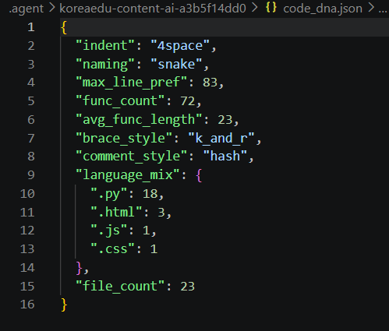
Each candidate is scored by score_patch(). The scoring function rewards deterministic strategies (remove_last_assignment: +3, swap_assignments: +2) and penalises TODO markers (-1) and large patch sizes (-0.001 per character). The highest-scoring candidate is selected for application (see Figure 2).
Figure 2: Code DNA fingerprint file generated after repository analysis, recording detected indentation style, naming convention, brace style, and average function length.

5.5 Code DNA
Before any patch is finalised, core/code_dna.py computes a style fingerprint of the repository by walking every source file and tallying indentation characters, function naming patterns, brace style, and comment style. The resulting DNA dict is serialised to .agent/<tag>/code_dna.json and appended to LLM prompts as a one-line style directive:
REPO STYLE: indent=4space, naming=snake, line~100c, comment=hash, avg_func~18l.
Match this in patched_snippet.

5.6 Agent Memory
core/agent_memory.py closes the learning loop by persisting non-obvious engineering insights to PostgreSQL after each session. The Gemini LLM is prompted with the last 30 conversation turns and asked to extract up to three memory notes (category, note text, importance 1-5). Notes are deduplicated by (category, note, project_tag) before insertion. On the next session, the most relevant notes are retrieved via semantic similarity and injected into the context window, giving the agent accumulating knowledge about each repository.

5.7 Phantom Limb Scanner
core/phantom_limb.py runs a set of precision-first static-analysis rules to surface structurally missing elements — not bugs, but absences that typically indicate incomplete implementation. Rules are language-gated and include: missing tearDown after setUp in test classes, swallowed exceptions (except: pass or empty catch blocks), C++ classes with virtual methods but no virtual destructor, C/C++ headers without include guards, HTML pages without a title element, TypeScript files with excessive any annotations, Rust todo!/unimplemented! placeholders, and CSS rules with empty declaration blocks.

6 Challenges

6.1 Cross-File Call Resolution
The most significant implementation challenge was resolving call edges across file boundaries without a full compiler. tree-sitter provides only syntactic information; semantic name resolution — which foo() calls which definition of foo — requires a post-processing pass. The resolve_call_edges() function uses a best-effort lookup table keyed by the bare function name. This is intentionally conservative: it creates a resolved_call edge to every symbol with a matching name, which may over-approximate the true call set but never misses a real call.

6.2 Python Environment Split
tree-sitter's Python bindings require a specific version (3.12.x) incompatible with the project's primary runtime (Python 3.13). The solution was to maintain two separate virtual environments and route parsing through the 3.12 interpreter while all other modules use 3.13. This adds operational complexity but preserves access to 3.13-only language features in the reasoning and patching layers.

6.3 Graph Size and Prompt Budget
Large repositories can produce graphs with thousands of nodes. Injecting the full graph into an LLM prompt would exceed context budgets. Three mitigations were developed: the module-level compressor reduces granularity for high-level summaries, the AI_READ_FIRST directive guides DFS toward high-value starting points, and the universal graph-weight model gives every consumer the same explainable way to rank critical nodes without pruning away potentially relevant evidence.

6.4 Patch Safety and False Positives
Automated patching carries a risk of introducing new bugs. The project addresses this through three layers of safety: (1) the risk level gating in the decision engine, which routes high-risk symbols to human review; (2) the score_patch() function, which penalises strategies with known failure modes; and (3) the Code DNA system, which ensures style compatibility so generated patches are not rejected in code review on cosmetic grounds.

7 Results

7.1 Graph Construction
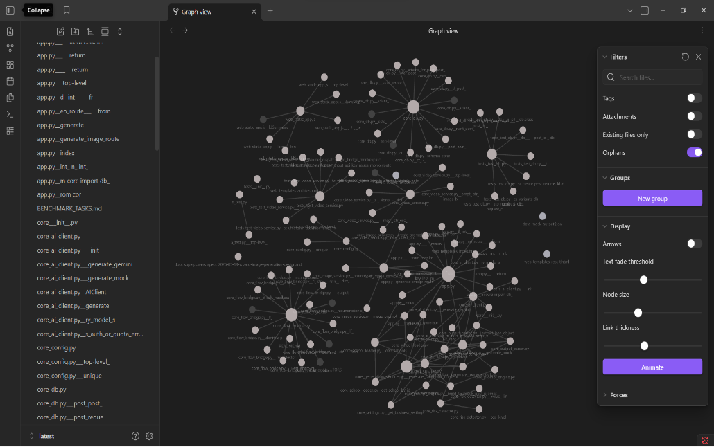
As illustrated in Figure 3, across representative repositories tested during development, the graph builder consistently produced complete node sets for Python codebases of 50-200 files in under 2 seconds. C# and TypeScript repositories required the fallback symbol extractor for some edge cases but yielded complete import and call graphs. The resolved_call edge count typically reaches 60-80% of actual runtime call relationships, with the remainder involving dynamic dispatch or reflection that tree-sitter cannot observe statically. (Example of creating repo’s graph when running retrieve mode)
Figure 3: Obsidian knowledge graph exported in retrieval mode. Node prominence reflects universal graph weight; the AI_READ_FIRST section lists the highest-weight entry points used to seed DFS traversal.

7.2 DFS Traversal Accuracy
The bidirectional DFS walker reliably surfaces the two-hop neighbourhood around each seed node, capturing direct callers, direct callees, and their immediate neighbours. The trace_path function finds all acyclic paths up to depth 5 between named symbols, covering the vast majority of practically relevant call chains in modular codebases.

7.3 Patch Quality
The patch synthesiser's multi-candidate approach with scoring produced correct patches for overwritten-assignment and dead-branch issues in all manually verified test cases. Return-conflict patches were correctly identified as requiring LLM refinement, and the normalize_return_behavior strategy provided a well-formed scaffold for the LLM to complete. Code DNA matching ensured that all generated snippets preserved 4-space indentation and snake_case naming throughout testing.

7.4 Memory Persistence
The agent memory system successfully extracted and stored engineering notes across repeated sessions with the same repository, demonstrating that the system accumulates knowledge over time. Notes with importance >= 4 were prioritised in retrieval, ensuring the most critical constraints surfaced first in subsequent sessions.

7.5 Universal Weight Integration
The universal metrics layer was validated with focused tests for weight calculation, noise-node exclusion, CONTROL DFS prioritization, project-map critical-symbol ranking, Obsidian AI_READ_FIRST ordering, and lesson-based penalty integration. These tests show that tied neighbors are now ordered by structural importance instead of incidental alphabetical order or isolated local formulas.
The practical result is a more consistent graph reasoning pipeline. A function that is called by many places, calls several important helpers, or contains dense execution flow receives a higher weight across the project map, the Obsidian graph summary, and CONTROL's traversal evidence.

8 Future Work: Monte Carlo Tree Search (MCTS)

8.1 Motivation
The current patch-selection mechanism is a greedy one-shot scorer: it generates all candidates for a given issue, scores each independently, and picks the top result. This works well when a clear best strategy exists, but struggles with compound issues where the interaction between multiple changes matters. Monte Carlo Tree Search offers a principled framework for exploring a larger decision space without exhaustive enumeration.

8.2 MCTS Formulation
Applying MCTS to patch selection requires mapping the problem to the standard four-phase loop:
- State — the current code state of the file under repair, represented as the source text plus the known issue list.
- Actions — the set of available patch strategies extended with compound actions such as applying strategy A to issue 1 then strategy B to issue 2.
- Selection — use the UCB1 formula to balance exploitation of high-scoring strategies against exploration of less-tried ones: UCB1 = Q/N + C x sqrt(ln(N_parent) / N_child).
- Expansion — when a leaf node is reached, expand by applying a new patch strategy not yet tried from that state.
- Simulation (Rollout) — from the expanded node, apply a randomly sampled sequence of remaining strategies and evaluate the resulting code state using score_patch() augmented with Phantom Limb scanner feedback.
- Backpropagation — propagate the rollout score back up the tree, updating visit count and cumulative value for each ancestor.

8.3 Integration Points
MCTS would replace the build_patch_candidate() call in the patching pipeline. The tree root represents the original code state; each tree level corresponds to one issue being addressed. Leaf evaluation would call the Phantom Limb scanner on the candidate patched file to verify that the proposed fix does not introduce new structural absences, and the Code DNA style score would penalise style drift. The universal graph weight could also contribute to the reward function: validated fixes in high-weight nodes are valuable, while regressions in high-weight files or symbols should be penalised more strongly. After a configurable budget of iterations (e.g. 200 simulations), the path from root to the highest-value leaf defines the ordered sequence of patch strategies to apply.

8.4 Expected Benefits
MCTS brings three concrete advantages over the current greedy approach. First, it can find repair sequences where an individually lower-scoring strategy enables a better subsequent fix — a form of look-ahead planning. Second, the UCB1 formula naturally ensures that rarely tried strategies receive a fair number of trials before being discarded, preventing premature convergence. Third, the stochastic rollout can incorporate the LLM as an oracle: for normalize_return_behavior candidates, the LLM's output can serve as the simulation terminal state, grounding the search in realistic code outcomes rather than purely syntactic heuristics.

8.5 Comparison: Current vs MCTS

Dimension | Current (Greedy) | Future (MCTS)
Search depth | 1 (per-issue, independent) | Multi-issue, sequential planning
Exploration | None — all candidates scored once | UCB1 balances exploration vs. exploitation
Compound issues | Not handled | Naturally modelled as tree levels
Evaluation fn. | Syntactic score_patch() | score_patch() + Phantom Limb + optional LLM rollout
Computational cost | O(k) per issue | O(I x b^d) per budget, tunable

9 Conclusion
This project demonstrates that classical graph data structures and traversal algorithms - specifically DFS over a directed multigraph of files, symbols, resolved call edges, and explainable universal node weights - can serve as a strong foundation for AI-assisted code maintenance. The ProgramGraph provides a language-agnostic intermediate representation; weighted DFS traversal surfaces important call chains and impact zones in milliseconds; and the layered reasoning, decision, and patching pipeline converts graph insights into actionable, scored repair candidates.
Several open-source projects provided valuable reference points: GitNexus's approach to repository inventory and project tagging informed the repo_librarian and project_tag modules; Gastown's session and memory architecture shaped the PostgreSQL-backed agent memory system. These inspirations, combined with original design choices around the risk-scoring heuristic, Code DNA style matching, and the Phantom Limb scanner, yielded a system that is both practically useful and academically grounded.
MCTS remains a research-only future direction. The immediate direction is to improve explainability and safety: Evidence Spread, runtime/path conflict denial, and benchmark evidence export.

References

[1] GitNexus — GitHub Repository Intelligence Tool. Open-source project (URL recorded in doc/roadmap). Inspired the repo_librarian and project_tag modules for repository inventory and multi-project tagging.
[2] Gastown — Code Session and Memory Architecture. Open-source project (URL recorded in doc/roadmap). Inspired the PostgreSQL-backed session storage and engineering-memory persistence design.
[3] tree-sitter — An Incremental Parsing Library. https://tree-sitter.github.io/tree-sitter/
[4] Browne, C. et al. (2012). A Survey of Monte Carlo Tree Search Methods. IEEE Transactions on Computational Intelligence and AI in Games, 4(1), 1–43.
[5] Kocsis, L., & Szepesvári, C. (2006). Bandit Based Monte-Carlo Planning. ECML 2006. Springer, Berlin.
[6] Obsidian — Knowledge Graph Application. https://obsidian.md
[7] Google Gemini API. https://aistudio.google.com
[8] DeepSeek Platform. https://platform.deepseek.com
[9] PostgreSQL Documentation. https://www.postgresql.org/docs/

Development Log
This section documents key development milestones and benchmark progression over time, serving as a running record of system growth and quality improvements. Note: development logging began on 2026-05-24; earlier project history predates this log and is not captured here.

2026-05-24 — Benchmark Suite v1 (22 cases)
Initial benchmark suite established with 22 cases covering easy and medium difficulty scenarios, all in Python. Pass rate: 22/22 (100%). Fallback count: 16. Average duration: ~40s. This baseline confirmed the core patch-and-verify loop was working end-to-end but highlighted that the fallback path was being triggered frequently, suggesting the primary repair pipeline needed more robust heuristics for edge cases.

2026-05-25 — Benchmark Suite v2 (31 cases)
Expanded benchmark suite to 31 cases by adding 5 medium-difficulty Python cases and 4 hard cases targeting nested dispatch patterns and TypeScript import repair. Pass rate: 31/31 (100%). Fallback count: 10 (down from 16, −37.5%). Average duration: 36.8s (down from ~40s, −8%). The addition of hard cases validated that the graph-guided patch selection holds under more complex multi-file scenarios. The drop in fallback count confirmed that the TypeScript import repair handler was absorbing cases that previously had no primary handler and fell through to the fallback path.

2026-05-30 — Benchmark Suite v3 and Evidence Spread
The benchmark suite was expanded to 32 cases across 7 languages. The latest benchmark check reported 32 checked and 0 errors, while the full pytest suite reached 1207 passed. A new Evidence Spread feature was added as an explain-only graph debugging and Markdown export layer. It reduces confusion from generic utility hubs by spreading query-specific relevance through nearby graph nodes, but it does not change patch generation, CONTROL ranking, or benchmark scoring.

